Exception handling Lab Questions (2023)

Q 1 Take two integers  and  as input, you have to compute  x/y . If   x and  y  are not  integers or if  is zero , exception will occur and you have to report it. Read sample Input/Output to know what to report in case of exceptions.

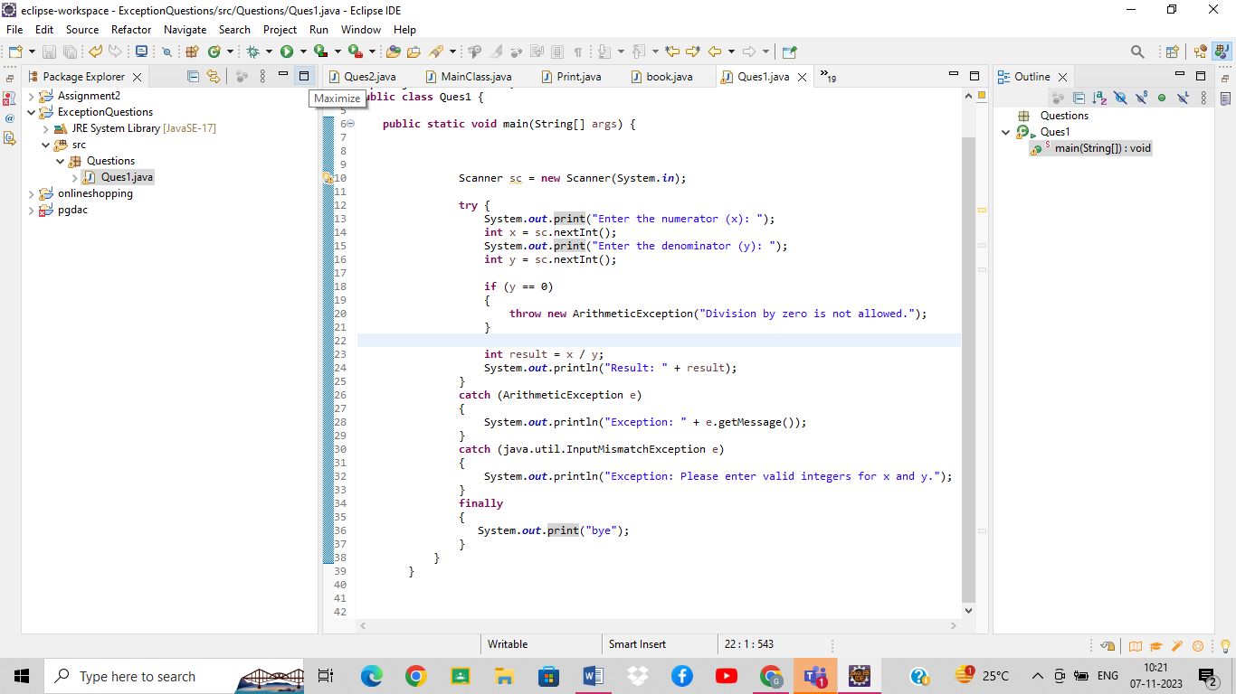

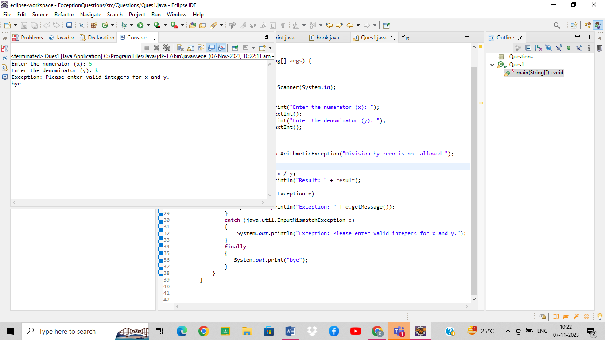

Q 2 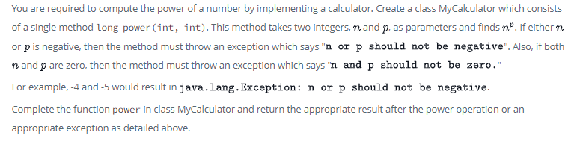

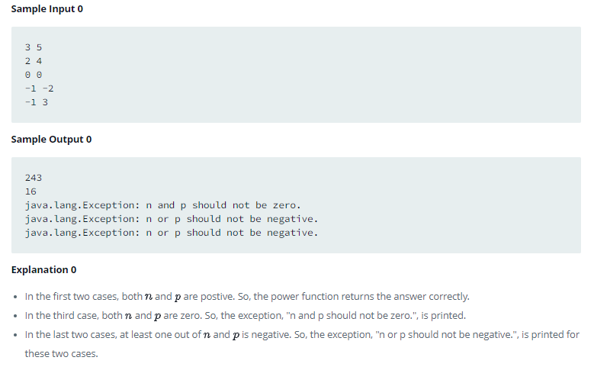

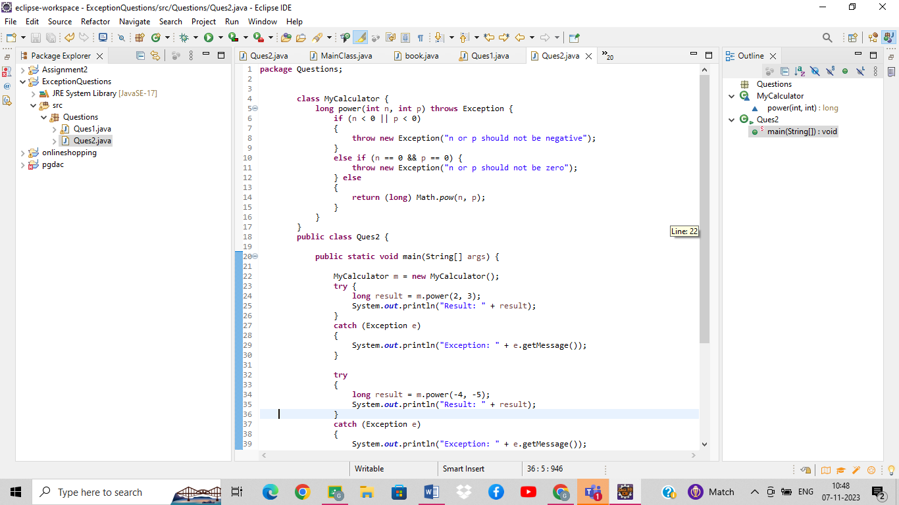

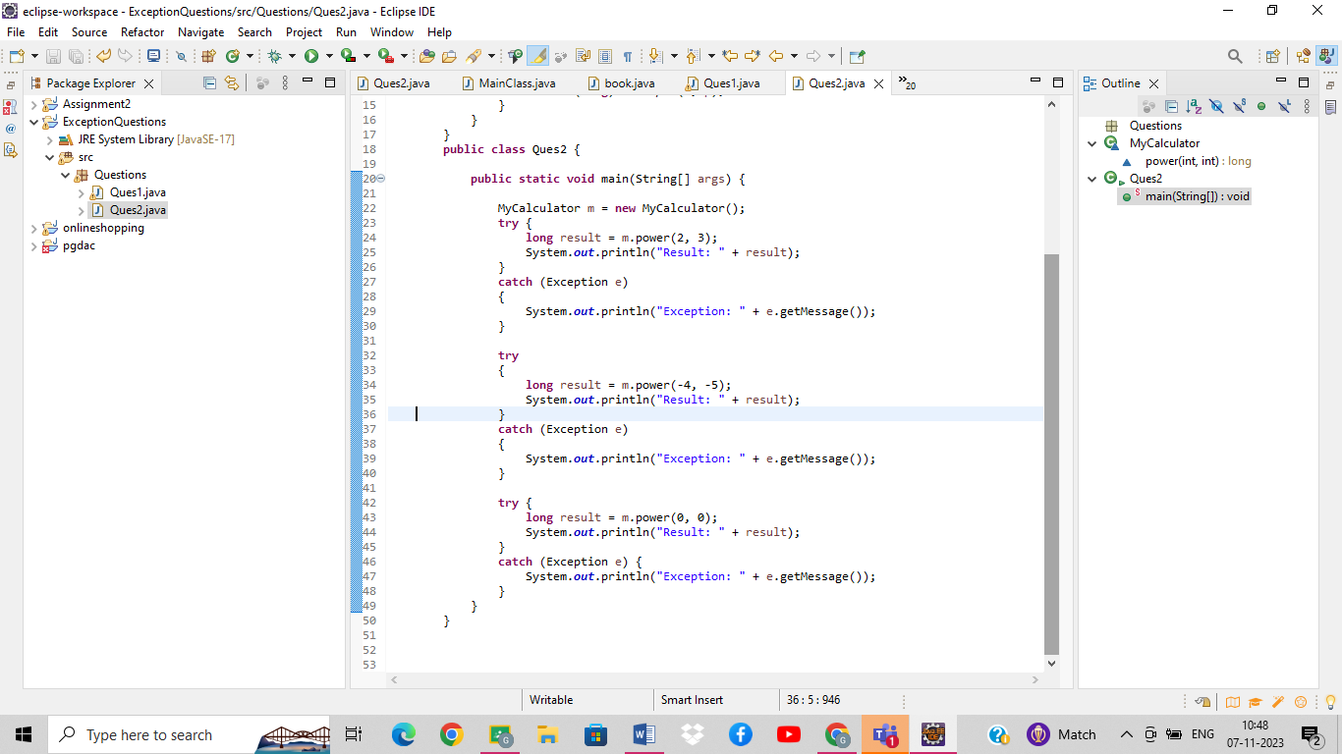

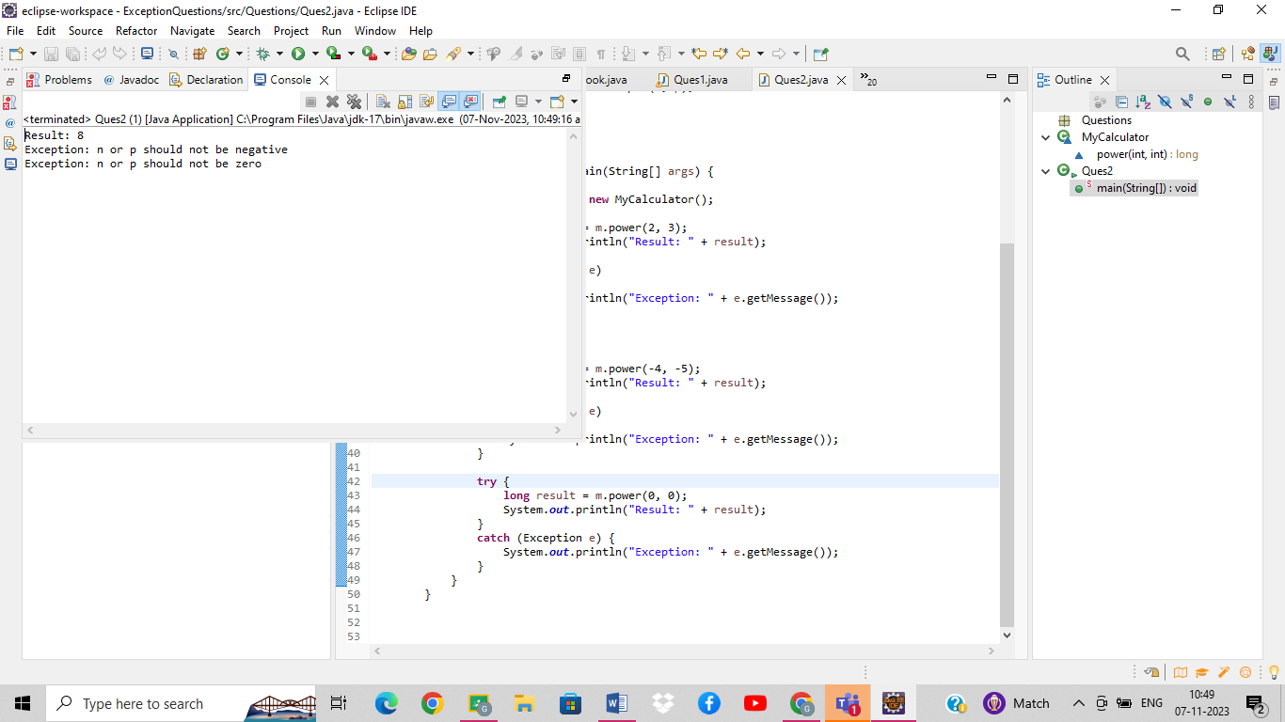

Q 3 Write a program for user defined Exception that checks the external and internal marks if the internal marks is greater than 40 it raise the exception internal mark is exceed, if the external mark is greater than 60 exception is raised and display the message the external marks is exceed, create the above exception and use it in your program.

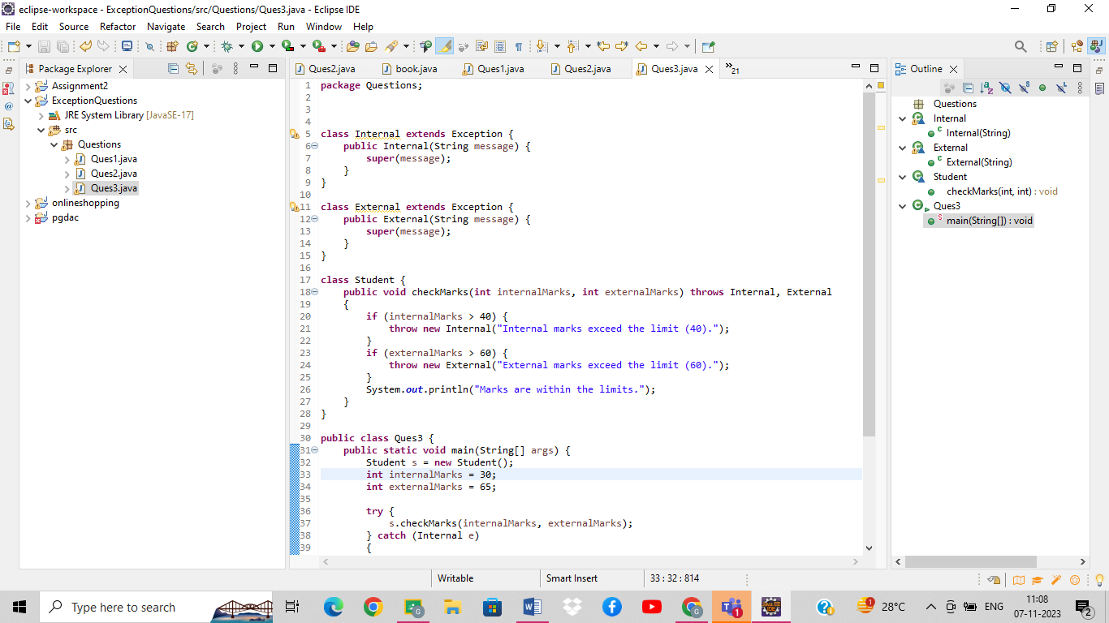

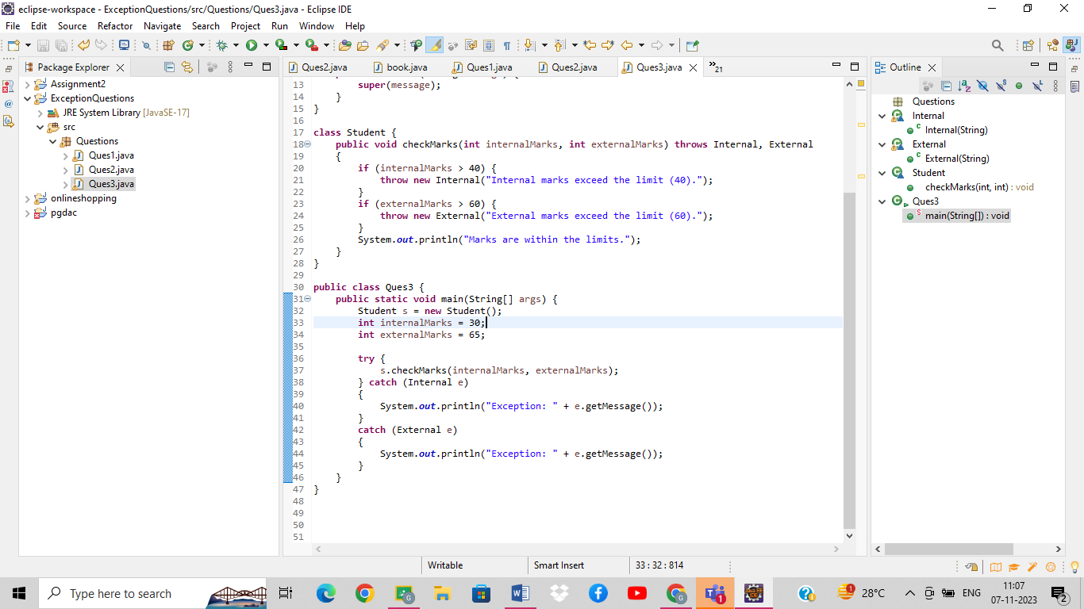

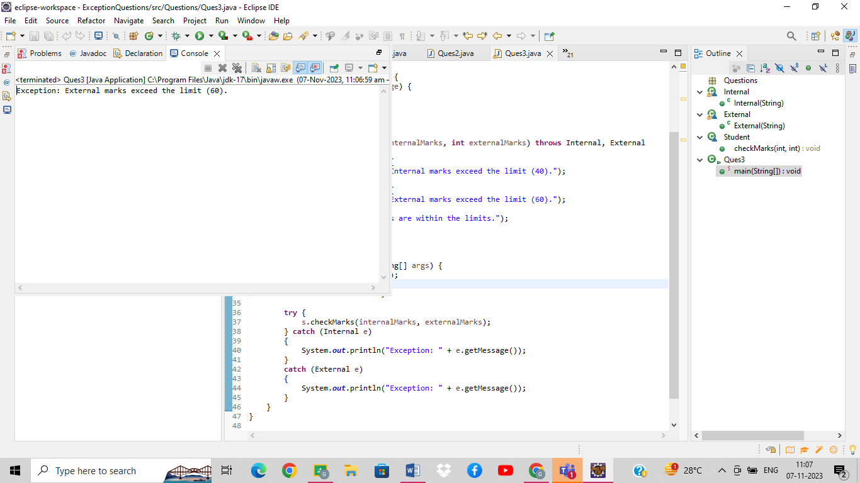

Q 4      Create a class Student with attributes roll no, name, age and course. Initialize values through parameterized constructor. If age of student is not in between 15 and 21 then generate user-defined exception “AgeNotWithinRangeException”. If name contains numbers or special symbols raise exception” NameNotValidException ”.

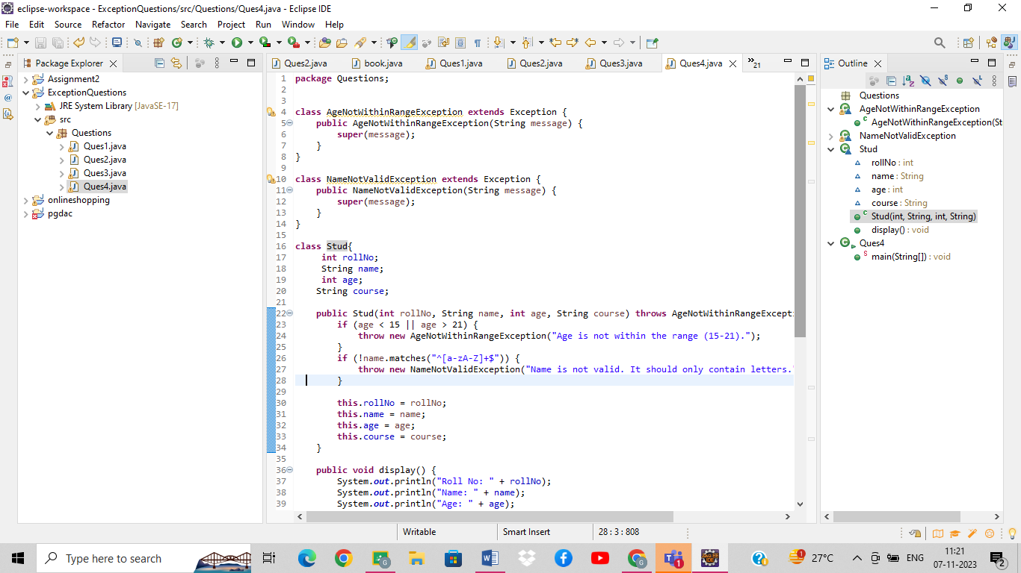

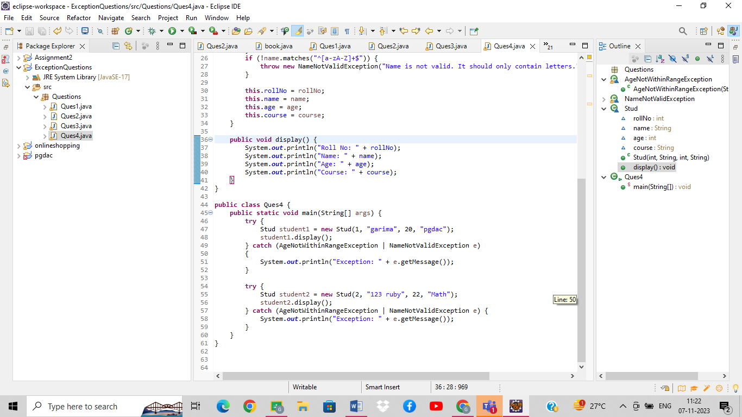

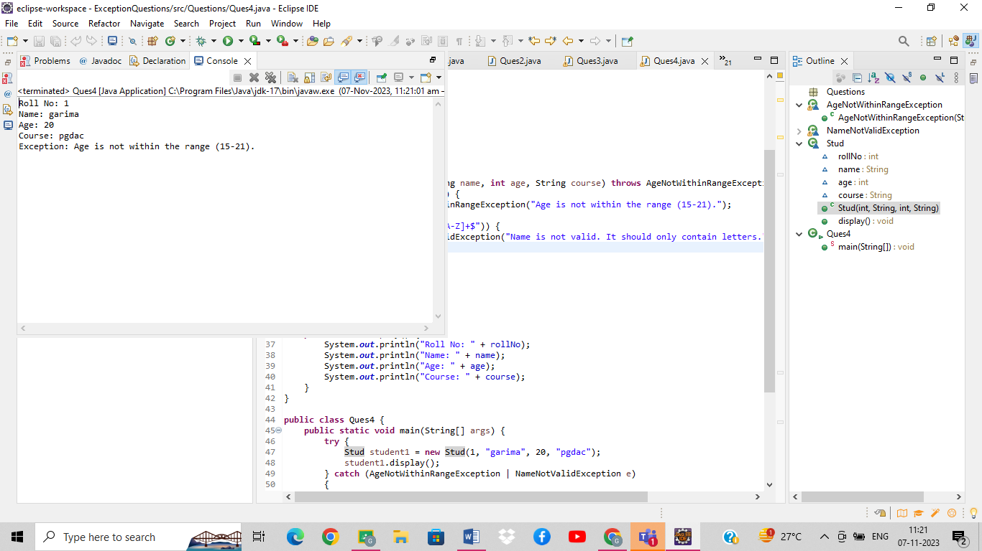

Q 5   Write a program to check all the three number entered by command line argument are greater than 10 , then print sum of those numbers . If any number is less then 10 then throw user defined exception “MyException” which print message number iis lesser then 10

“ 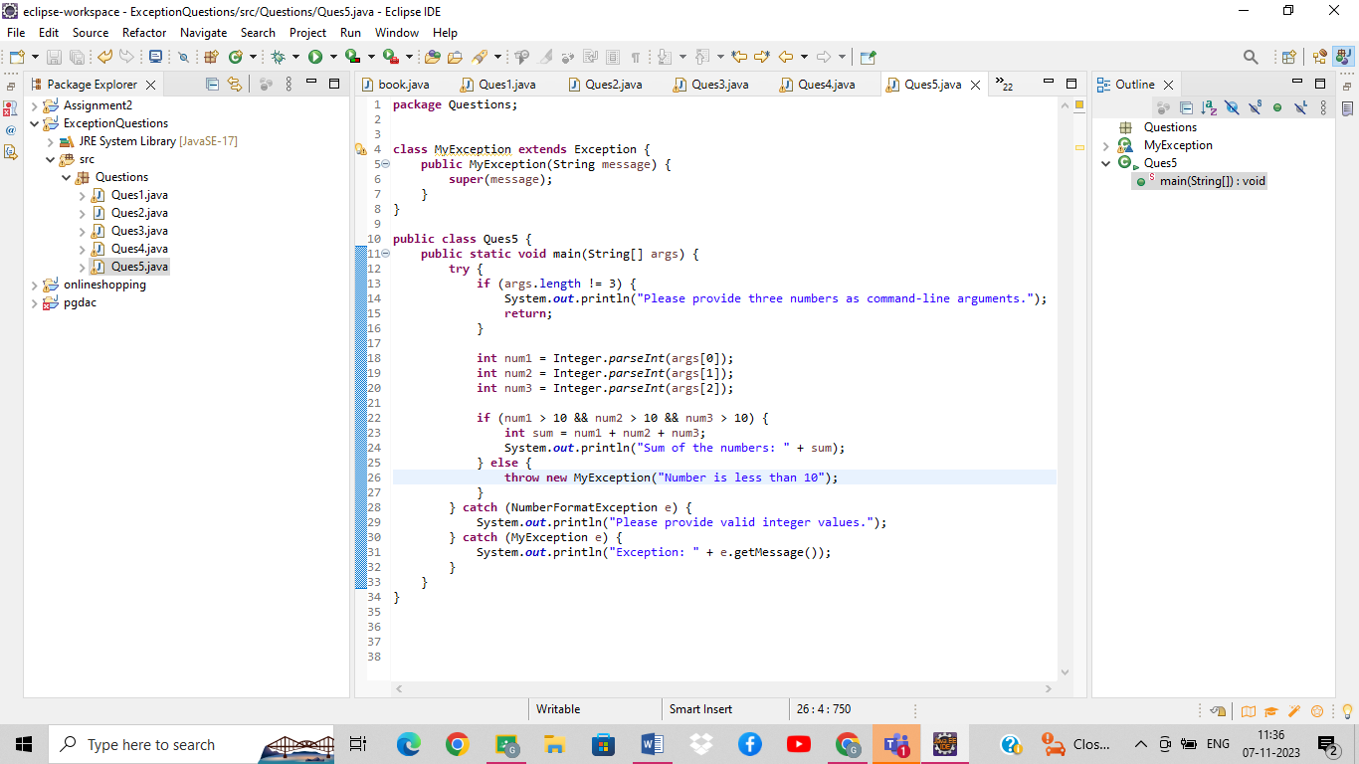

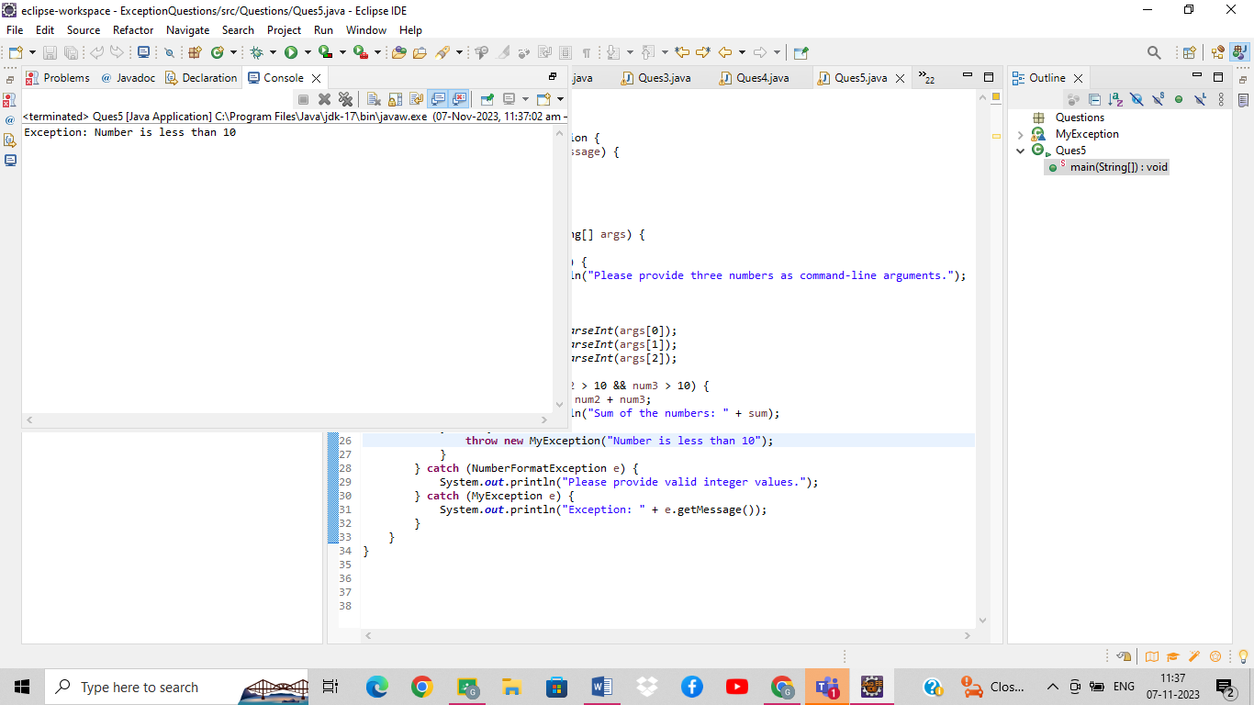

Q 6 create a program to demonstrate constructor channing .

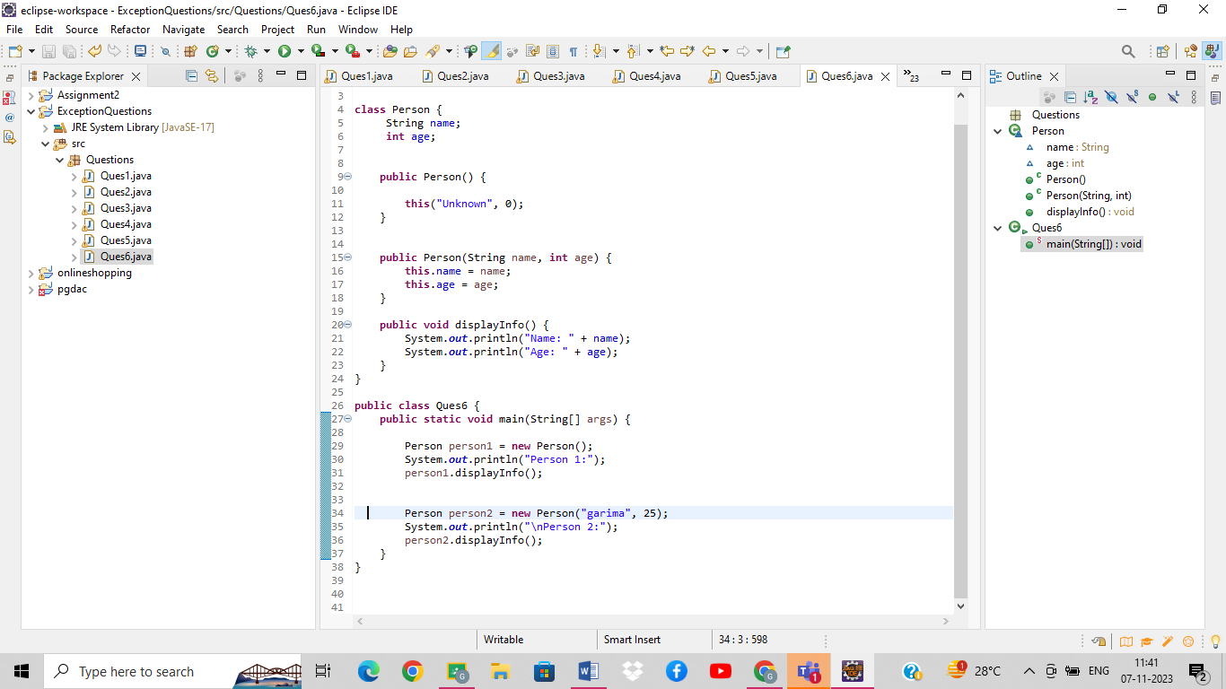

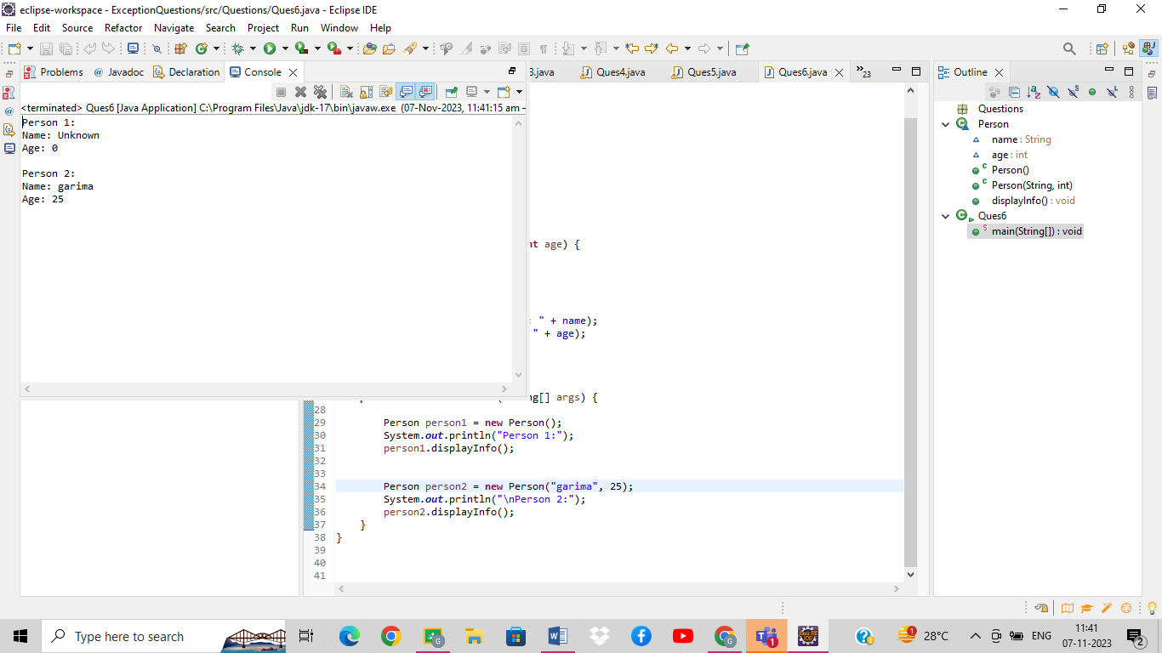

Q 7 Write a program that define interface Admission having abstract method registration

Create another class Student in separate file having method Addstudent ()

1. In Addstudent create local class Mtech student that inherits Admission interface
2. In same method  also create anonymous class that also inherits Admission interface

In both above classes implement registration method

In main call AddStudent method of student class.